Lab Report 7

*Name: Sricharan Vinoth Kumar*

*Roll no: 2024112022*

*Group no: 10*

Experiment 1:

* Objective:

To build a decade counter that outputs to a 7-segment display through a decoder.

* Electronic Components Required:
  + 74HC93 4-bit Ripple counter.
  + CD4511 7-segment decoder.
  + 7 Segment display.
  + Jumper Wires
  + Digital Test Kit
* Reference Circuit:

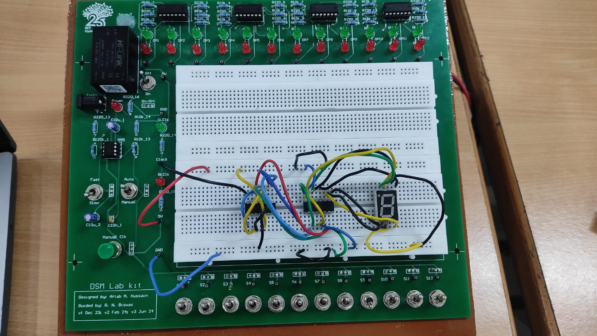

* Procedure:
  + Ensure that the input pins IP1-12 and output LEDs LG1-12 and LR1-12 are working.
  + Assemble the circuit as per the given circuit diagram.
  + Connect the MR pins of the counter to the pins Q1 and Q3, in order to make it a decade counter.
  + If the 7-segment display is a common anode display, connect the COM pins to 5v.
  + Observe the working of the circuit.
* Observation:

The display counts from 0 to 9 and resets to 0 after.

* Conclusion:

A decade counter has been successfully assembled and its output has been displayed through a 7-segment display.

* TinkerCAD Simulation:

<https://www.tinkercad.com/things/7GNzbMAkc1p-dsm-lab-7-exp-1?sharecode=cnToxFEB3oL78ULj9MRzZgUXNnU9QHGX1-qMk3TNbGE>

Experiment 2:

* Objective:

To understand the working of an 8-bit serial register using an Arduino.

* Electronic Components Required:
  1. 74HC595 8-bit serial register.
  2. Arduino Uno
  3. Jumper Wires
  4. Digital Test Kit
* Reference Circuit:

* Procedure:
  1. Ensure that the input pins IP1-12 and output LEDs LG1-12 and LR1-12 are working.
  2. Assemble the circuit as per the given circuit diagram.
  3. For Part A
     1. Program the Arduino to count from 0 to 255 without hardwiring the outputs.
  4. For Part B
     1. Program the Arduino to get a user input of 0-8 and light up the corresponding output LED.
* Observation:

The circuit counts from 0-255 for part A and displays the corresponding LED as per the user input for part B.

* + Arduino Code Of Part A:

// Pin connections for 74HC595

const int dataPin = 11; // DS (Data pin)

const int latchPin = 10; // ST_CP (Latch pin)

const int clockPin = 13; // SH_CP (Clock pin)

byte counter = 0; // 8-bit counter variable

void setup() {

// Set pins as output

pinMode(dataPin, OUTPUT);

pinMode(latchPin, OUTPUT);

pinMode(clockPin, OUTPUT);

}

void loop() {

// Update counter

counter++;

// Send data to shift register

digitalWrite(latchPin, LOW); // Prepare shift register for data

shiftOut(dataPin, clockPin, MSBFIRST, counter); // Shift out the 8-bit counter value

digitalWrite(latchPin, HIGH); // Output the shifted data to Q0-Q7

delay(500); // Delay for visualization (adjust as needed)

}

* + Arduino Code For Part B:

const int dataPin = 2;

const int latchPin = 4;

const int clockPin = 3;

void setup() {

pinMode(dataPin, OUTPUT);

pinMode(latchPin, OUTPUT);

pinMode(clockPin, OUTPUT);

Serial.begin(9600);

Serial.println("Enter a number between 1 and 8:");

}

void loop() {

if (Serial.available() > 0) {

int number = Serial.parseInt();

if (number >= 1 && number <= 8) {

byte ledPattern = 1 << (number - 1);

digitalWrite(latchPin, LOW);

shiftOut(dataPin, clockPin, MSBFIRST, ledPattern);

digitalWrite(latchPin, HIGH);

Serial.print("Glowing LED: ");

Serial.println(number);

}

while (Serial.available()) {

Serial.read();

    }

  }

}

* Conclusion:

The working of the 8bit register has been understood.

* TinkerCAD Simulation:
  + Part A: <https://www.tinkercad.com/things/e5qW1fkyNfp-dsm-lab-7-exp-2a?sharecode=oBvgx6qVsIfQbjAjNkwVuWAqkKev7xNXGZqXvQt7kRE>
  + Part B: <https://www.tinkercad.com/things/5BhLj11jMlr-dsm-lab-7-exp-2b?sharecode=LDRh5xVt8UJaUiXaM2Nwps0jkgeCjVZoEWFFzySpMv4>